

**A**

**MINI PROJECT REPORT**

ON

**“ONLINE SERVICE BOX”**

Submitted in the partial fulfillment of the requirements in the 4th semester of

**BACHELOR OF ENGINEERING**

**IN**

**INFORMATION SCIENCE AND ENGINEERING**

BY

**GONDRALA SAI SHARANYA-[1NH18IS035]**

**FOR**

**COURSE NAME: MINI PROJECT**

**COURSE CODE :20ISE59**

***Under the guidance of***

**Dr. Arvind Shivappa Kapse** Professor, Dept. of ISE, NHCE

**DEPARTMENT OF INFORMATION SCIENCE AND ENGINEERING**

**NEW HORIZON COLLEGE OF ENGINEERING**

(Autonomous College Permanently Affiliated to VTU, Approved by AICTE, Accredited by NAAC with ‘A’ Grade & NBA)

Ring Road, Bellandur Post, Near Marathahalli,

Bengaluru-560103, INDIA



**CERTIFICATE**

Certified that the project work entitled **“ONLINE SERVICE BOX”** carried out by **Ms**. **GONDRALA SAI SHARANYA**, USN **1NH18IS035**, a bonafide student of V semester in partial fulfillment for the award of Bachelor of Engineering in Information Science and Engineering of New Horizon College of Engineering, an Autonomous institute under the Visvesvaraya Technological University, Belagavi during the year 2020-21. It is certified that all corrections/suggestions indicated for Internal Assessment have been incorporated. The project report has been approved as it satisfies the academic requirements in respect of Project work prescribed for the said Degree.

**Signature of the Guide** **Signature of the HOD Signature of the Principal**

Dr. Arvind Shivappa Kapse Dr. R.J Anandhi Dr. Manjunatha

**Examiners:**

**Name Signature**

1. …………………………………………………. ………………………………..
2. …………………………………………………… …………………………………

**ABSTRACT**

Online Service Box is a web application which allows users to choose the type of service they require. Easy to use and helps users to connect for necessary services easily. The services provided are Driver, Mechanic, Pandit, Photographer etc. All the employees must have been registered by the organization.

PHP language with database(phpmyadmin), html, CSS and Javascript are used to implement this project. Users must first open the web page, login/signup with your Email-id and password and then select the type of service provided in the application, fill their details, book for the same along with the time slot (wherever required) and pay on cash or through card/Paytm etc. after the service is done.

Admins will be able to view the database, add or remove the employees, check customer details and make other necessary changes if needed.

**ACKNOWLEDGEMENT**

Any project is a task of great enormity and it cannot be accomplished by an individual without support and guidance. I am grateful to a number of individuals whose professional guidance and encouragement has made this project completion a reality.

I have a great pleasure in expressing my deep sense of gratitude to the beloved Chairman **Dr. Mohan Manghnani** for having provided me with a great infrastructure and well-furnished labs.

I take this opportunity to express my profound gratitude to the Principal **Dr.Manjunatha** for his constant support and management.

I am grateful to **Dr. R J Anandhi** , Professor and Head of Department of ISE, New Horizon College of Engineering, Bengaluru for his strong enforcement on perfection and quality during the course of my project work.

I would like to express my thanks to the guide **Dr. Arvind Shivappa Kapse** , Senior Assistant Professor, Department of ISE, New Horizon College of Engineering, Bengaluru who has always guided me in detailed technical aspects throughout my project.

I would like to mention special thanks to all the Teaching and Non-Teaching staff members of Information Science and Engineering Department, New Horizon College of Engineering, Bengaluru for their invaluable support and guidance.

**GONDRALA SAI SHARANYA**

**1NH18IS035**

**TABLE OF CONTENTS**

**CHAPTER 1……………………………………………………………………………………………………1**

INTRODUCTION

1. PROBLEM DEFINITION 1

2. PROPOSED SYSTEM 1

3. OBJECTIVES 2

4. ADVANTAGES AND DISADVANTAGES 2

**CHAPTER 2……………………………………………………………………………………………….....3**

ANALYSIS AND DESIGNING

1. REQUIREMENTS 3

2. ARCHITECTURE 4

**CHAPTER 3……………………………………………………………………………………………………5**

IMPLEMENTATION

1. HTML 5
2. CSS 6

3. PHP 6

4. JAVASCRIPT 6

5. DATABASE(MYSQL) 7

6. MODULES 8

**CHAPTER 4………………………………………………………………………………………………….10**

CODE SNIPPETS 10

**CHAPTER 5………………………………………………………………………………………………….17**

EXPECTED OUTCOMES 17

**CHAPTER 6………………………………………………………………………………………………….32**

1. FUTURE DEVELOPMENT 32
2. CONCLUSION 32

**REFERENCES……………………………………………………………………………………………….32**

**CHAPTER 1**

**INTRODUCTION**

* Web applications play a prominent role in today’s world. It is easier to maintain a proper communication between customers and organizations.
* Online Service Box is a web application that allows users to select the local services provided according to their requirement.
* Services provided are Tutor, Driver, Mechanic, Appliances repair etc.
* Simple registration process and it uses system database which saves time, space and paper.

**PROBLEM DEFINITION**

* In the current system, it is difficult to contact or book a service we require.
* This project provides all the local service details and user can book a service with the time slot according to his/her requirement, make the payment and once the service is done, the user can give the feedback.
* Users can cancel it any time before the service if they wish to cancel.

**PROPOSED SYSTEM**

* HTML, CSS and JAVASCRIPT are used here as front end which are the most portable languages used in GUI applications.
* PHP is used as back end with database connectivity in phpMyAdmin using XAMPP server.
* Designing a web page for users, consisting of different services available and a login/signup page will appear for user to get registered by providing their details and these details are stored in the database followed by the booking page and also cancel button if user wishes to cancel booking.

**OBJECTIVES**

* To be able to build an interface that can connect public to local service providers.
* To produce a web-based system with database connectivity that allow a customer to register with his /her details and book the required service.
* To be able to design an interactive GUI using html, CSS and JavaScript to make it user-friendly.
* To produce efficient and secured management system.
* Also allows users to cancel their orders

**ADVANTAGES**

* A convenient way for users to book for any local service provided and can also specify date and time.
* Database helps to manage the information of all entities in a systematic manner.
* Addition and deletion of records are simpler and easier to perform on the database.
* This application is simple, easy and efficient way to use.

**DISADVANTAGES**

* This application requires internet connection.
* The expected amount to be paid may vary (Example:-In case of home appliances repair, if there is any part has to be replaced then user has to pay the amount of the part going to be fixed).

**CHAPTER 2**

**ANALYSIS AND DESIGNING**

**HARDWARE REQUIREMENTS**

* Processor : above 500 Mhz
* RAM : 4GB/6GB
* Input Devices : Keyboard and mouse
* Output Devices: High resolution monitor

**SOFTWARE REQUIREMENTS**

* Operating system: Windows10
* Server : XAMPP version 7.4.11
* Text-Editor : Notepad++ version 7.9

**ARCHITECTURE**

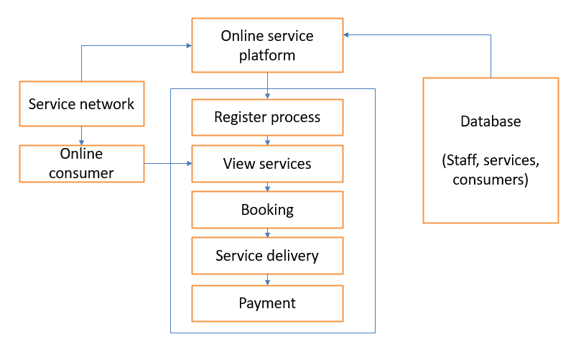

Customer/consumer must have active internet connection as every process is done in an online platform. The customer must first have to register by providing their username(email-id) and password. If the customer has already registered then he/she can just login and go to the home page. In the home page, customer can find all the local services provided by the organization and click on the service they require which takes them to booking page. Here, the user has to fill the form by providing their details like name, contact, type of service, date and time of service etc. All these details are stored in the database. Then the service is delivered according to the details provided by the users and finally payment has to be done.

Admins can add or remove employees (service providers), display users and make changes in the database if needed.

**CHAPTER 3**

**IMPLEMENTATION**

**HTML**

Html is the called as the “mother tongue” of your browser and abbreviated as “HyperText Mark-up Language”. We can edit program with bold, bullets, headings, italics and other font styles, size and colors. With Cascading - Sheets and Java-Script, it forms a triple of cornerstone technology for the world. HTML5 is used in this project.

It was invented by Tim Berner’s Lee in 1990. Html is used to make websites. The file of html must be saved using the extension.html in order to run the html program use any browser.

Structure of html that has to be specified to the browser is:

<html> ------> Marks the beginning of the HTML file

<head> ------> Beginning of the heading section

<title>…..</title> ------> Title that appears on the browser menu bar

</head> ------> End of the heading section

<body> ------> Begins the body section (text contained inside the

body section can be used with different font style,

size, background color, link etc.

</body> ------> End of the body section

</html> ------> Defines the end of the HTML document

**Tables**

A table is a matrix of cells. Leftmost column contains row labels and top most row contain column labels. Content of the table is specified by using the <table> tag. Table row is created using <tr> tag and table column can either be created using <td> or <th> tag.

**Forms**

Forms are used to collect input from the user. This is the most common way that is used to communicate to the user through web browsers to servers. Fields that can be added to the form are: Text field, Password field, Drop-down menu, Radio Button, reset button etc.

Ex: 1. For text field - <input type=”text”>

2. For submit button - <input type=”submit”>

**CSS**

CSS is abbreviated as cascading style sheets. Presence of CSS in html files states the look and layout of content. Both external and document-level style sheets are used in this project. It allows multiple web pages to share formatting by specifying the relevant CSS. Different divisions are created with simple selectors, generic selectors, class selectors, id selectors. Font styles, font size and font colors and other font properties and positional elements are implemented.

**JAVASCRIPT**

Javascript is a dynamically typed scripting language which can be used both on the client-side and server-side that allows you to make web pages interactive. It is an object-based language. The number of data members and methods of an object can change during execution. Interactions with users through form elements, such as buttons or menus or alert boxes, can be conveniently described in JavaScript. Scripts can appear directly as the content of a <script tag> and type attribute of script has to be set to “text/javascript”.

In this project, javascript is used to create alert or popup messages when user fills and submits the form and also when user cancels his/her order.

**PHP**

PHP: Hypertext Preprocessor is a server-side scripting language that runs when the server receives a request for a web page via a web browser. The best things in using PHP are that it is very much simple for a new - comer, but offers many advanced features for a programmer. It is one of the best options if we have to secure our website. The php framework is a secured framework that can protect it against malware and virus attacks.

PHP files usually contains html tags and other scripting code and these scripts are executed on the server. In this project php has database connectivity with phpMyAdmin and using XAMPP server(apache). We can add, delete, modify or update data. It is used for user-access control and can collect form data.

**DATABASE-MYSQL**

Structured collection of data is called as database. Software that can create and maintain database is called as database management system. The most efficient relational database management system is used here. Every organization has large amount of data to be stored so this database can be used by each and every organization for better utilization of resources.

DBMS serves as an interface between database and end users or application programs, ensuring that data is properly organized and easily accessible. Table in a database is a collection of data organized in form of rows and columns. Record is a single entry in the database. Rows of the database are called as tuples and columns as attributes. Keys such as primary key, foreign key, candidate key, alternate key, super key) are used to identify the relation between database tables.

PhpMyAdmin database with XAMPP server is used in this project. Database contains data tables for users, employees/service providers, login for users, login for admins and type of services.

**SQL** is a structured query language includes creation, fetching rows, modifying rows and deletion. It helps to store, manipulate and retrieve the data in relational database model. And all these operations can be performed using two types of SQL commands: DDL and DML commands.

**ADVANTAGES OF DATABASE**

* Today the database is used everywhere and all walks of life. The database is becoming the backbone of all the software from standalone, client-server, mainframe, supercomputers etc.
* The results of database are presented in a form which is simple and easy to understand.
* Shows the whole description of business and store the details of customers.
* Manage the information of all entities in a systematic manner.
* Addition and deletion of records are simpler and easier to perform on the database.

**Modules**

LOGIN PAGE

USER LOGIN

ADMIN LOGIN

CANCEL

BOOKING

FILL

DETAILS AND BOOK

LOGIN AND SELECT SERVICE

DISPLAY

USERS

LOGIN

ADD OR REMOVE EMPLOYEE

• Sign up - This is a basic registration form in which user adds some basic details like name, username, password to login. This is a mandatory step for all users.

• Login - This page is used for authenticating the user in the databases by checking the username and password from the database.

• Welcome - This page is the first page after logging into the website. It greets the user by welcoming the customer to the website and show all type of local services provided by the organization in which customers can select a service according to their choice.

• Booking - The customers can click on the service and fill their details such as name, contact, service type, date, time etc. An alert box will appear saying that the order is booked when customer click on submit.

• Cancel order - This option is present on the home page as well as the thanking page after booking. In case if customer wish to cancel the service booked then he/she can click on cancel and enter their email-id to cancel their booking.

• Add employee - This is a dynamic form where admin is allowed to add 1 employee at a time into the account.

• Delete employee - This is a dynamic form where admin is allowed to add 1 employee at a time into the account.

• Display customers - This is a dynamic form where admin is allowed to view all customers of online service box.

• Logout - This option is present on the welcome/home page of the website, allowing users to log out at any point of time. For admins, this option is present in the admin page.

**CHAPTER 4**

**CODE SNIPPETS**

**Database tables/entities**

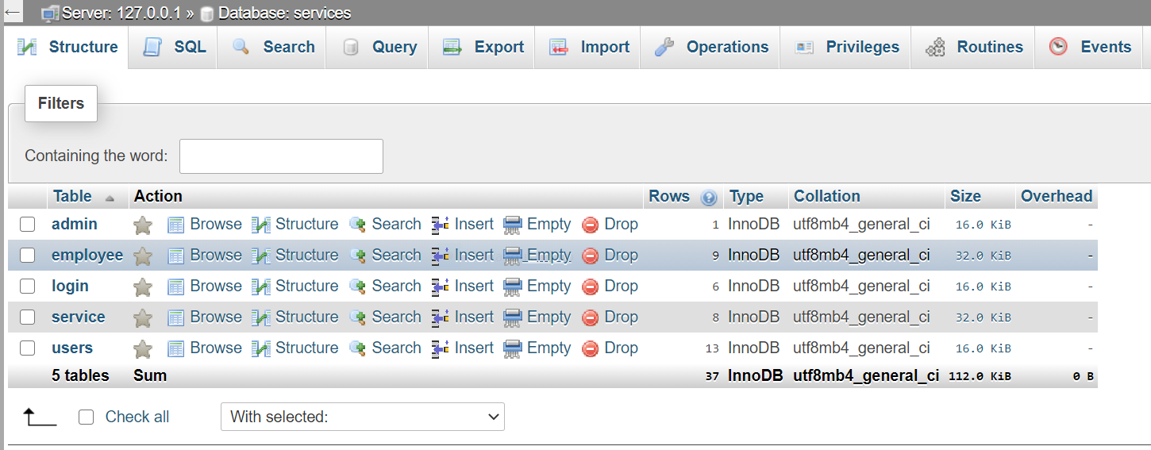

**LOGIN FOR ADMIN**

CREATE TABLE `admin` (

`username` varchar(40) NOT NULL,

`pass` varchar(40) NOT NULL

) ENGINE=InnoDB DEFAULT CHARSET=utf8mb4;

INSERT INTO `admin` (`username`, `pass`) VALUES

('admin123@gmail.com', 'admin');

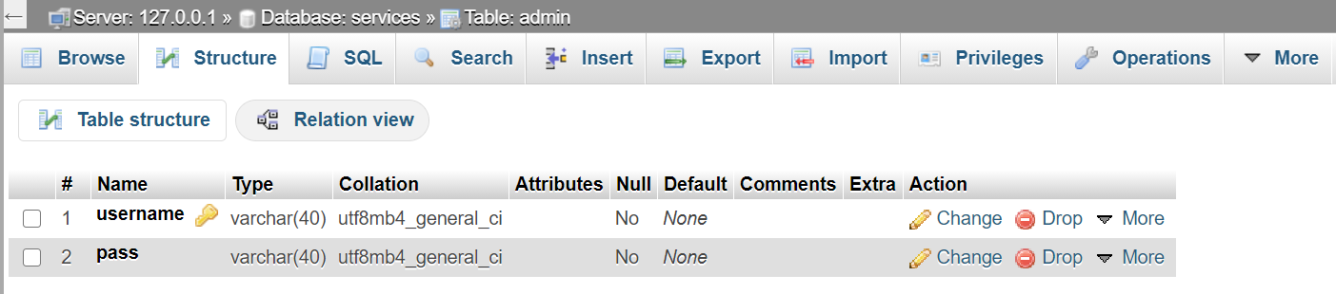

Here there are two attributes username and password(pass) where username is a primary key.

**LOGIN FOR USERS**

CREATE TABLE `login` (

`username` varchar(30) NOT NULL,

`pass` varchar(20) NOT NULL

) ENGINE=InnoDB DEFAULT CHARSET=utf8mb4;

INSERT INTO `login` (`username`, `pass`) VALUES

('abc@gmail.com', '123'),

('def456@gmail.com', 'def456'),

('harika@gmail.com', '!678'),

('sai34@gmail.com', '!sai34'),

('shanmuk@gmail.com', 'shanmuk'),

('shiv@gmail.com', 'shiv');

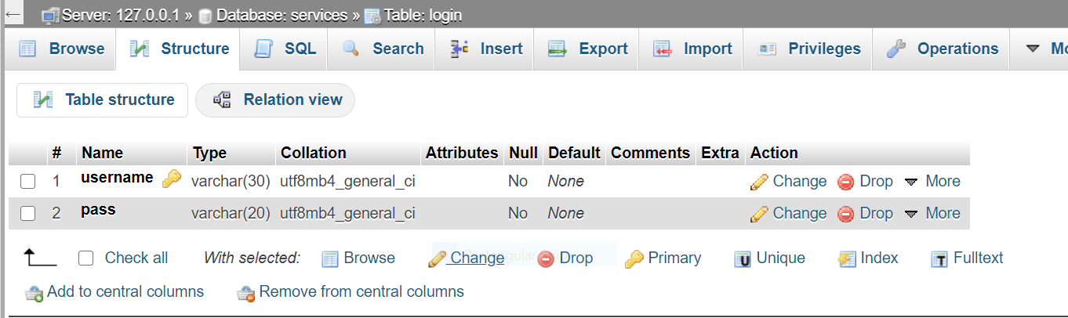

Here there are two attributes namely username and password(pass) where username is the primary key.

**SERVICE TYPES**

CREATE TABLE `service` (

`service_id` int(11) NOT NULL,

`service_name` varchar(20) NOT NULL

) ENGINE=InnoDB DEFAULT CHARSET=utf8mb4;

INSERT INTO `service` (`service_id`, `service_name`) VALUES

(1, 'tutor'),

(2, 'mechanic'),

(3, 'driver'),

(4, 'beautician'),

(5, 'photographer'),

(6, 'home appl repair'),

(7, 'catering'),

(8, 'pandit'),

(9, 'maid/cook');

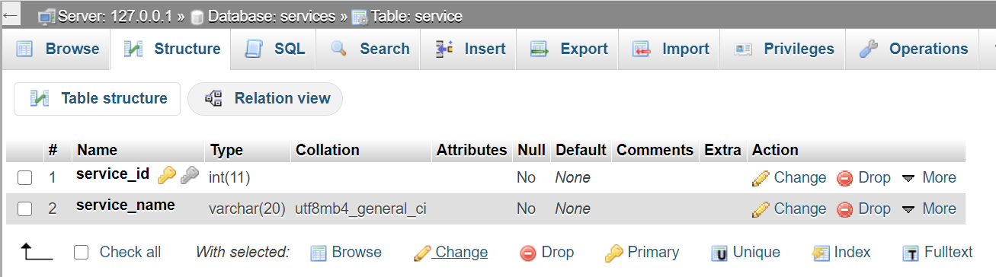

Here there are two attributes service_id and service_name where service_id is the primary key.

**Employees/service providers**

CREATE TABLE `employee` (

`emp_id` int(10) UNSIGNED NOT NULL AUTO_INCREMENT,

`emp_name` varchar(30) NOT NULL,

`gender` varchar(10) NOT NULL,

`address` varchar(60) NOT NULL,

`profession` varchar(20) NOT NULL,

`age` int(11) NOT NULL,

`emp_contact` bigint(20) NOT NULL

) ENGINE=InnoDB DEFAULT CHARSET=utf8mb4;

INSERT INTO `employee` (`emp_id`, `emp_name`, `gender`, `address`, `profession`, `age`, `emp_contact`) VALUES

(1, 'Dheeraj', 'male', '#106,5th main,2nd cross,jp nagar,bangalore', 'photographer', 30, 9087653289),

(2, 'Shwetha', 'female', 'No.59,2nd main,3rd cross,jayanagar 3rd block,bangalore', 'catering', 38, 7890476890),

(4, 'Pradeep', 'male', 'No.89,2nd main,3rd cross,rajajinagar,bangalore', 'appliance repair', 30, 9087653209),

(5, 'Anish', 'male', '#567,3rd cross,abc colony,whitefield,bangalore', 'pandit', 38, 7766500987),

(7, 'Geetha', 'female', '#690,B main,xyz colony,bannerghatta,bangalore', 'maid', 38, 7890476898),

(8, 'Sanjay', 'male', 'No.36,3rd main,6th cross,V.V.Extension,hoskote,banglore', 'driver', 30, 9089786700),

(13, 'Ashish', 'male', 'No.44,1st main,4th cross,surabhinagar,bangalore', 'mechanic', 40, 9089632269),

(15, 'Shubha', 'female', 'No.56,1st main,5th cross,kasturinagar,bangalore', 'tutor', 33, 8009765480),

(16, 'uday', 'male', 'No.70,2nd main,6th cross,K.R.puram,bangalore', 'tutor', 25, 8879006790);

(17, 'Rani', 'female', 'No.90,1st main,4th cross,Kadubisanahalli,bangalore', 'beautician', 25, 8879060870);

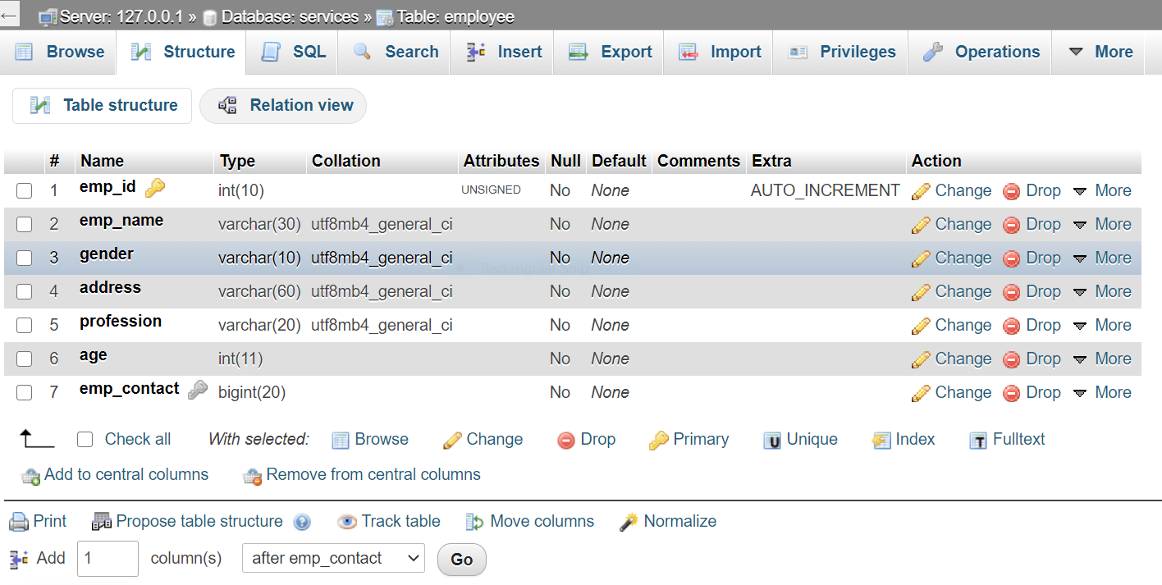

In this table, there are 7 attributes namely emp_id, emp_name, gender, address, profession, age, emp_contact where emp_id is the primary key given as auto increment and emp_contact is the unique key.

**DETAILS OF USERS**

CREATE TABLE `users` (

`user_id` int(10) UNSIGNED NOT NULL AUTO_INCREMENT,

`service_id` int(11) NOT NULL,

`name` varchar(40) NOT NULL,

`address` varchar(100) NOT NULL,

`contact` bigint(20) NOT NULL,

`email` varchar(40) NOT NULL,

`service_type` varchar(100) NOT NULL,

`date` date NOT NULL,

`time` time NOT NULL,

`time_to` time NOT NULL,

`to_address` varchar(70) NOT NULL,

`company_type` varchar(40) NOT NULL,

`num_persons` int(11) NOT NULL,

`note` varchar(100) NOT NULL,

`emp_id` int(11) NOT NULL

) ENGINE=InnoDB DEFAULT CHARSET=utf8mb4;

INSERT INTO `users` (`user_id`, `service_id`, `name`, `address`, `contact`, `email`, `service_type`, `date`, `time`, `time_to`, `to_address`, `company_type`, `num_persons`, `note`, `emp_id`) VALUES

(1, 1, 'Sai', '#106,4th main,2nd cross,jp nagar,bangalore', 7890657389, 'saisharanyabgl20@gmail.com', 'Class 11-12(python pgm)-Rs.3000/month', '2020-12-24', '03:00:00', '00:00:00', 'NA', 'NA', 0, 'NA', 15),

(3, 6, 'janani', 'No.99,2nd main,3rd cross,jayanagar 4th block,bangalore', 8009765400, 'janani90@gmail.com', 'Water purifier-Rs.300', '2020-12-24', '01:00:00', '00:00:00', 'NA', 'L.G', 0, 'servicing', 4),

(5, 8, 'Anitha', 'No.26,3rd main,6th cross,V.V.Extension,hoskote,bangalore', 8877609890, 'anitha90@gmail.com', 'House opening ceremony', '2020-12-25', '07:00:00', '01:15:00', 'NA', 'NA', 0, 'NA', 5),

(6, 9, 'Karthik', 'No.40,1st main,4th cross,surabhinagar,bangalore', 7890599080, 'karthik70@gmail.com', 'Home deep Cleaning(2BHK)-Rs.4000', '2020-12-14', '01:20:00', '00:00:00', 'NA', 'NA', 0, 'NA', 7),

(10, 5, 'Raj kumar', 'No.50,3rd main,4th cross,banashankari,bangalore', 7890479079, 'rajk890@gmail.com', 'photo shoot-Rs.2000', '2020-12-30', '15:00:00', '16:50:00', 'NA', 'NA', 0, 'NA', 1),

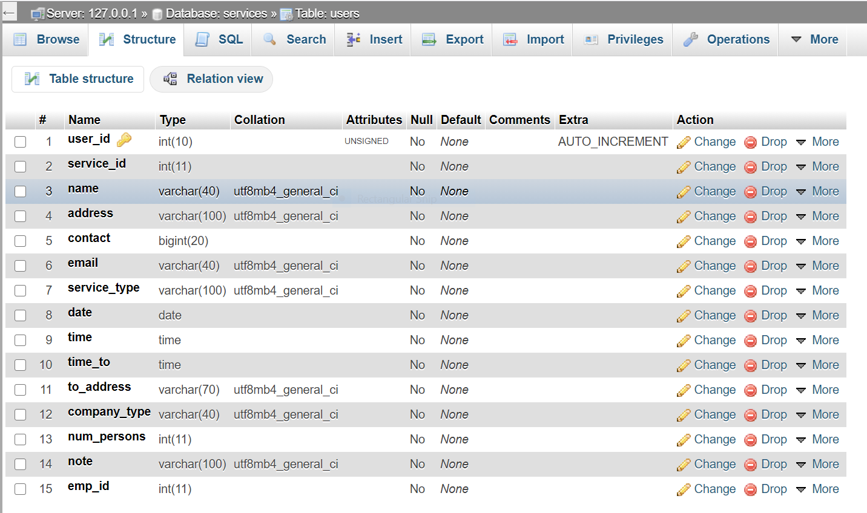

Here there are 15 attributes in which user_id is the primary key which is getting auto incremented. And service_id and emp_id are foreign keys.

**CHAPTER 5**

**EXPECTED OUTCOMES**

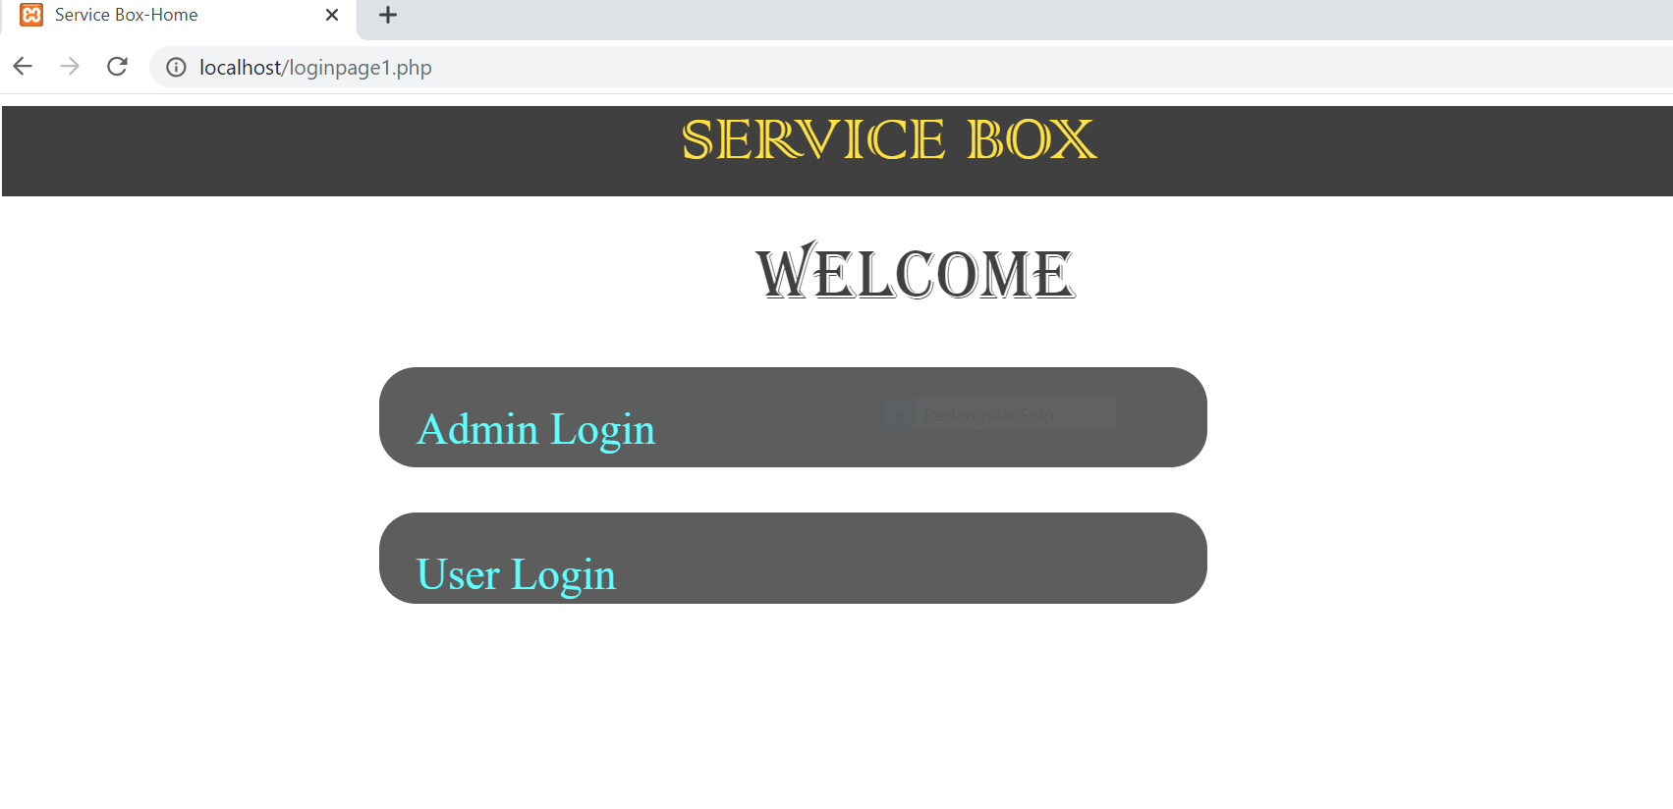

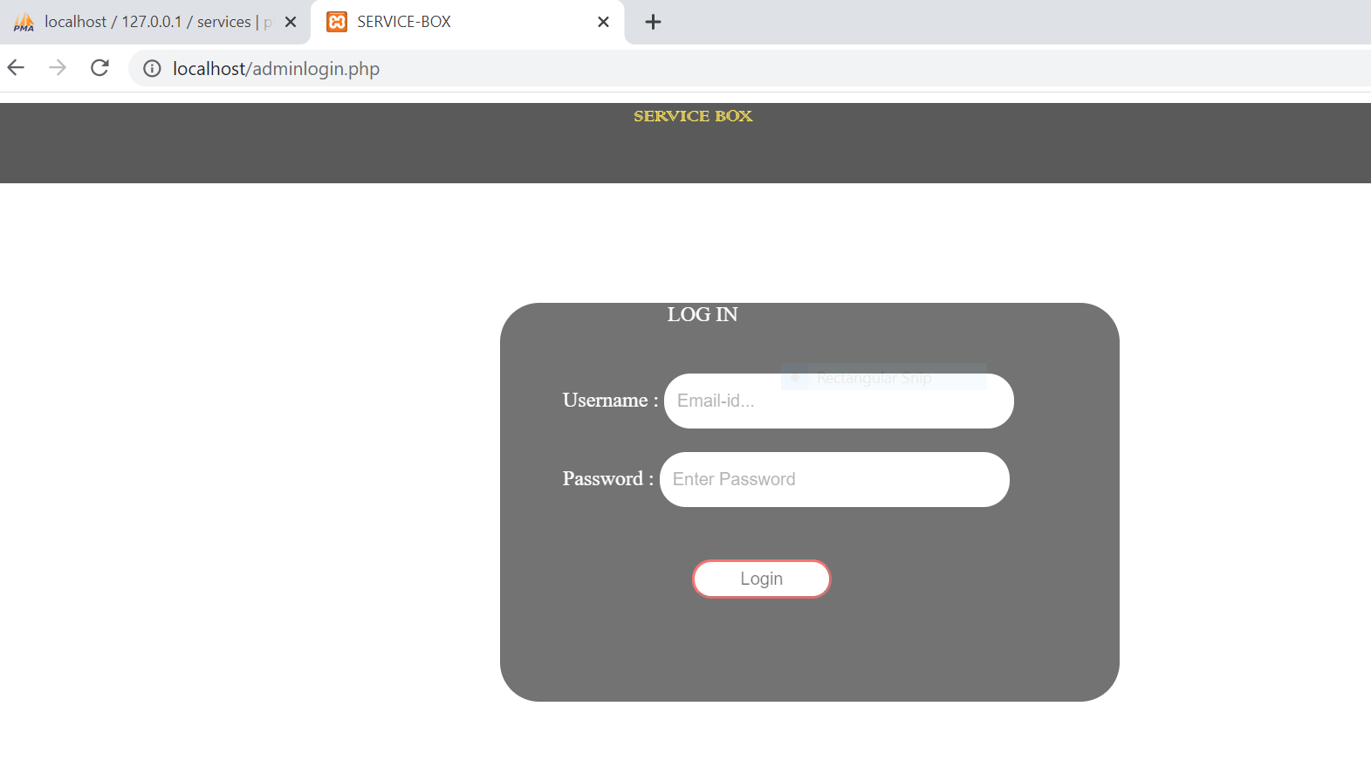

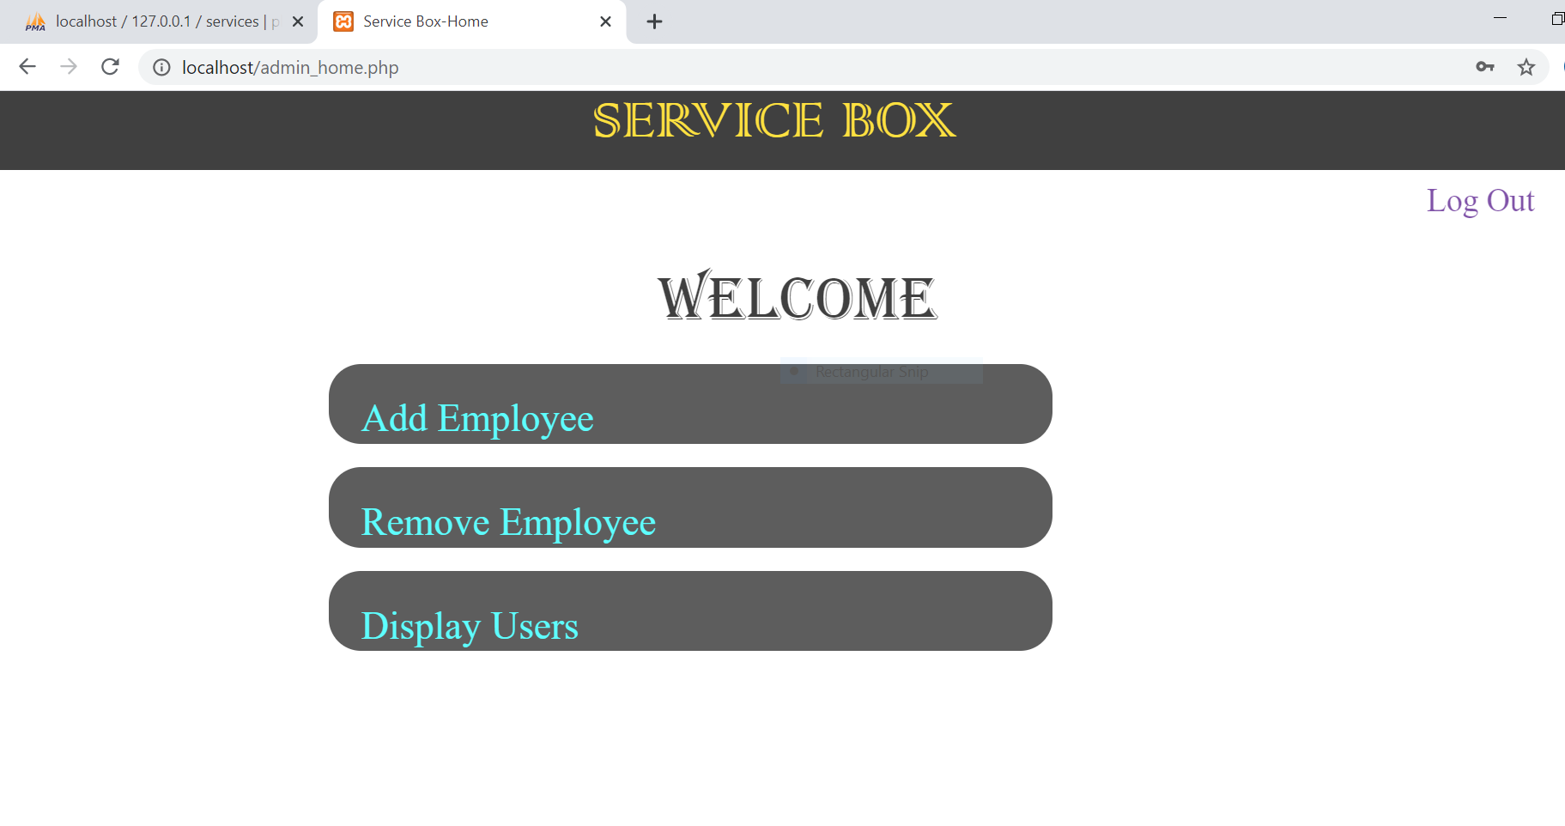

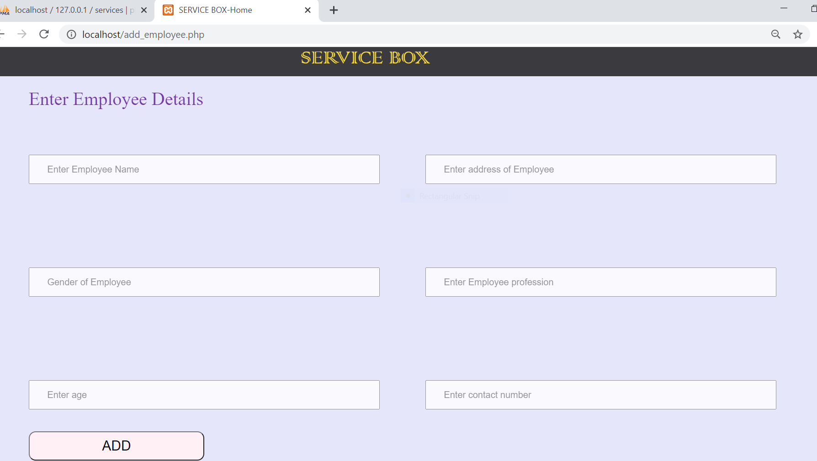

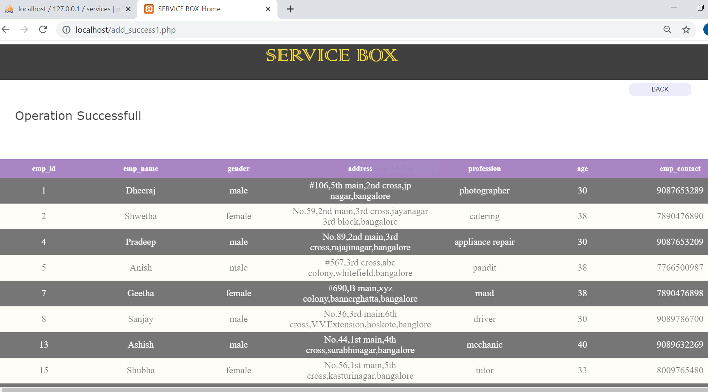

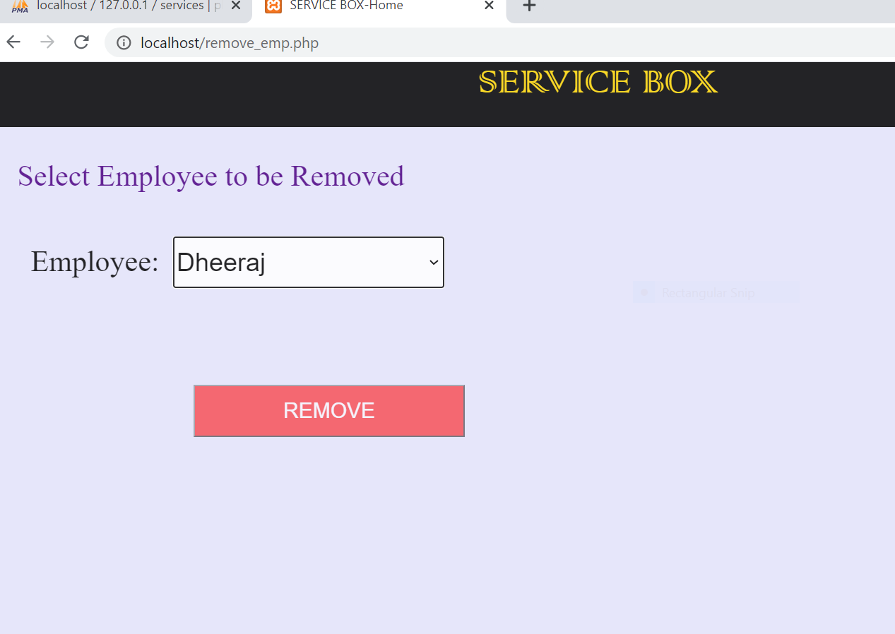

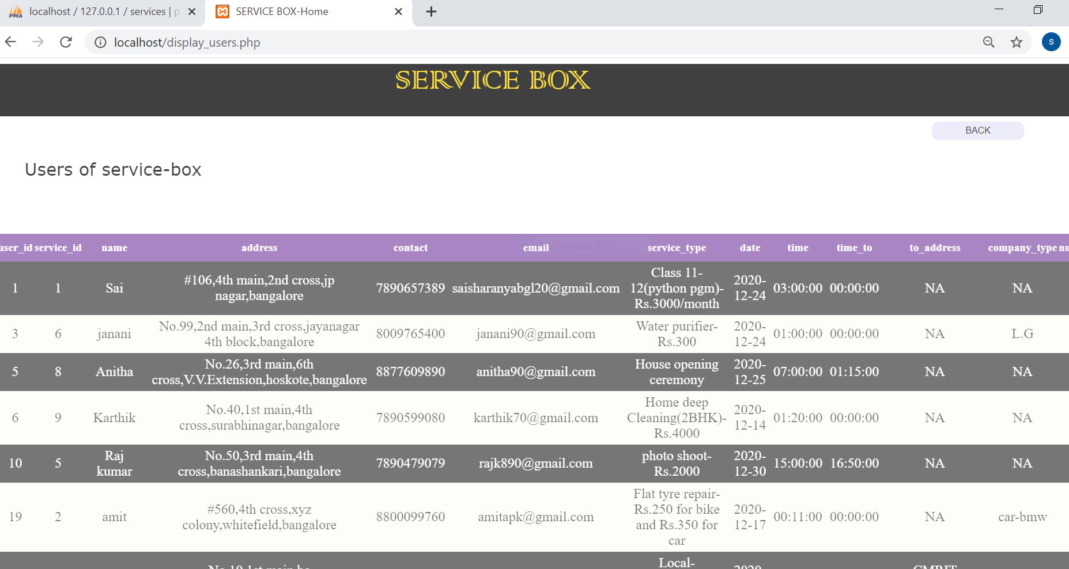

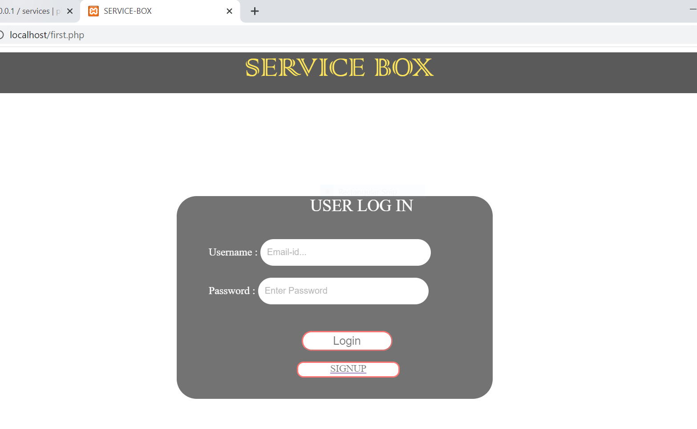

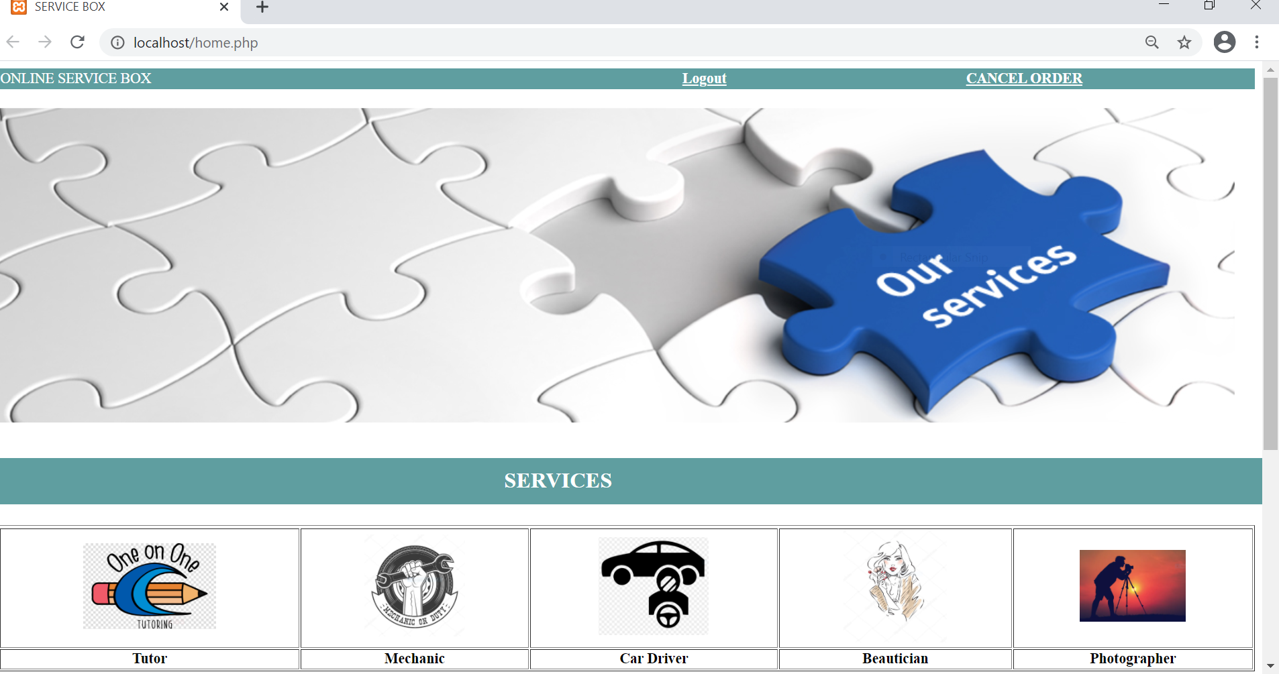

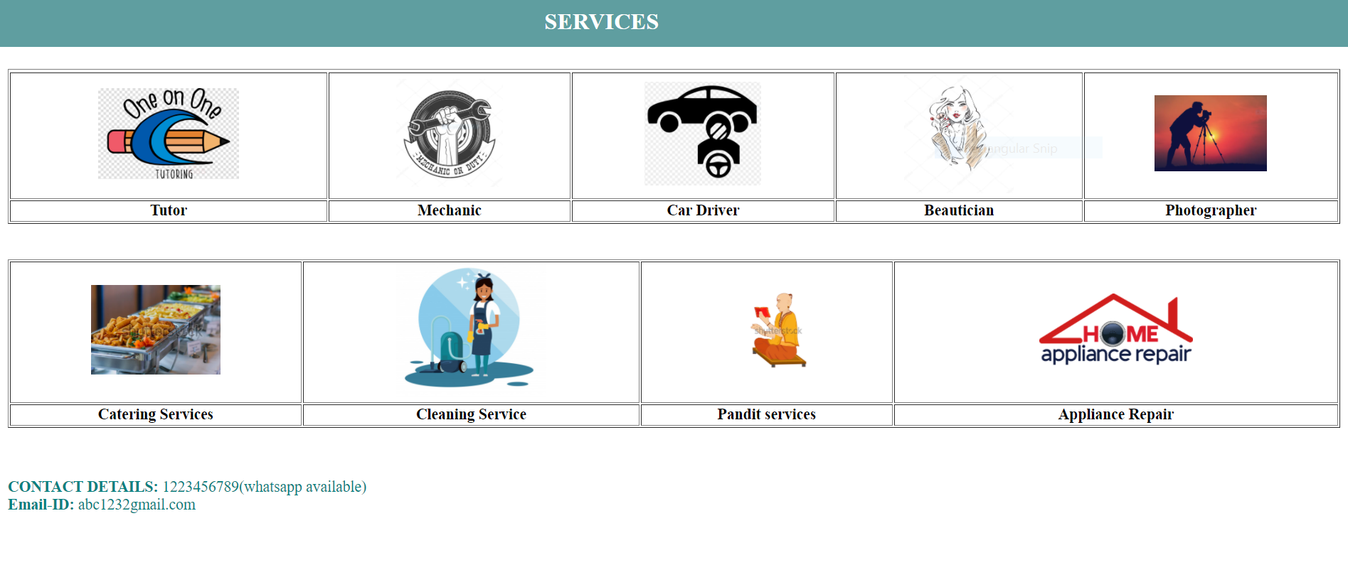

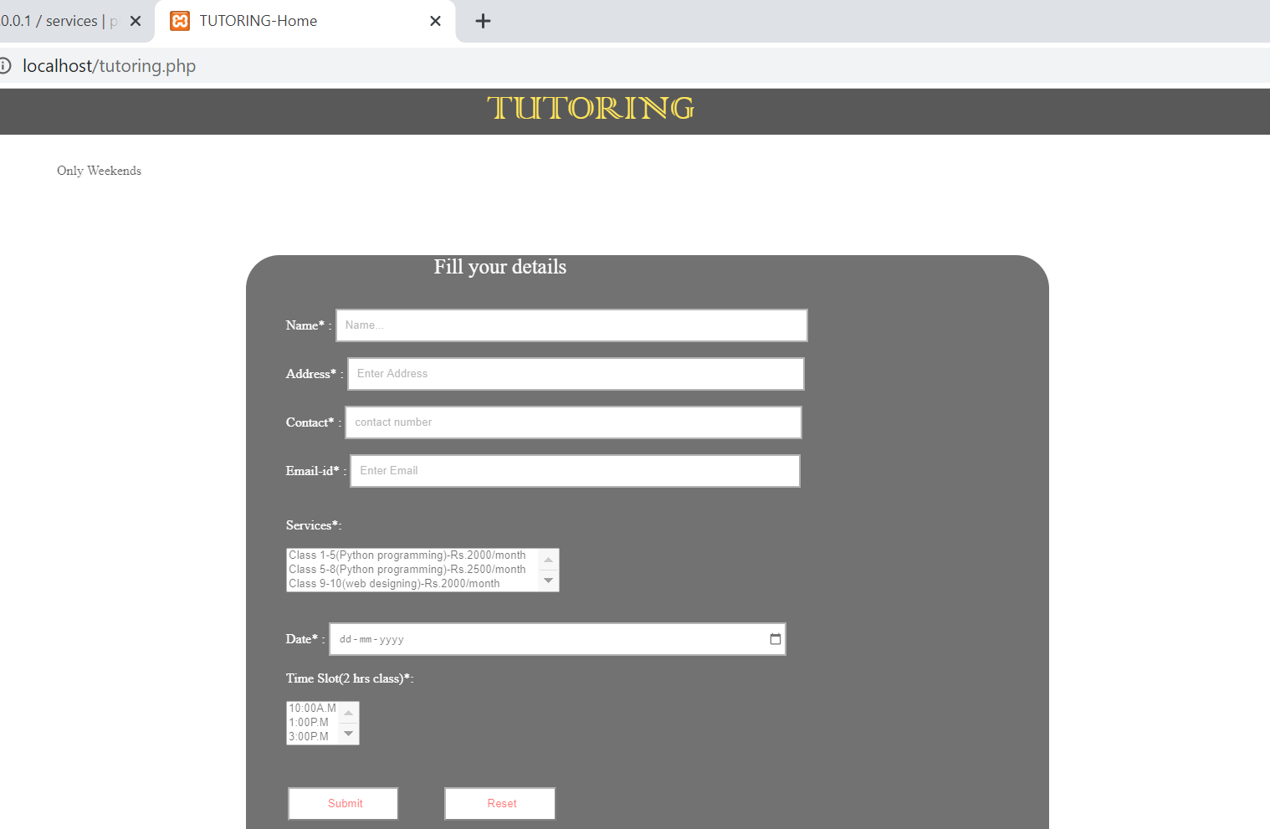

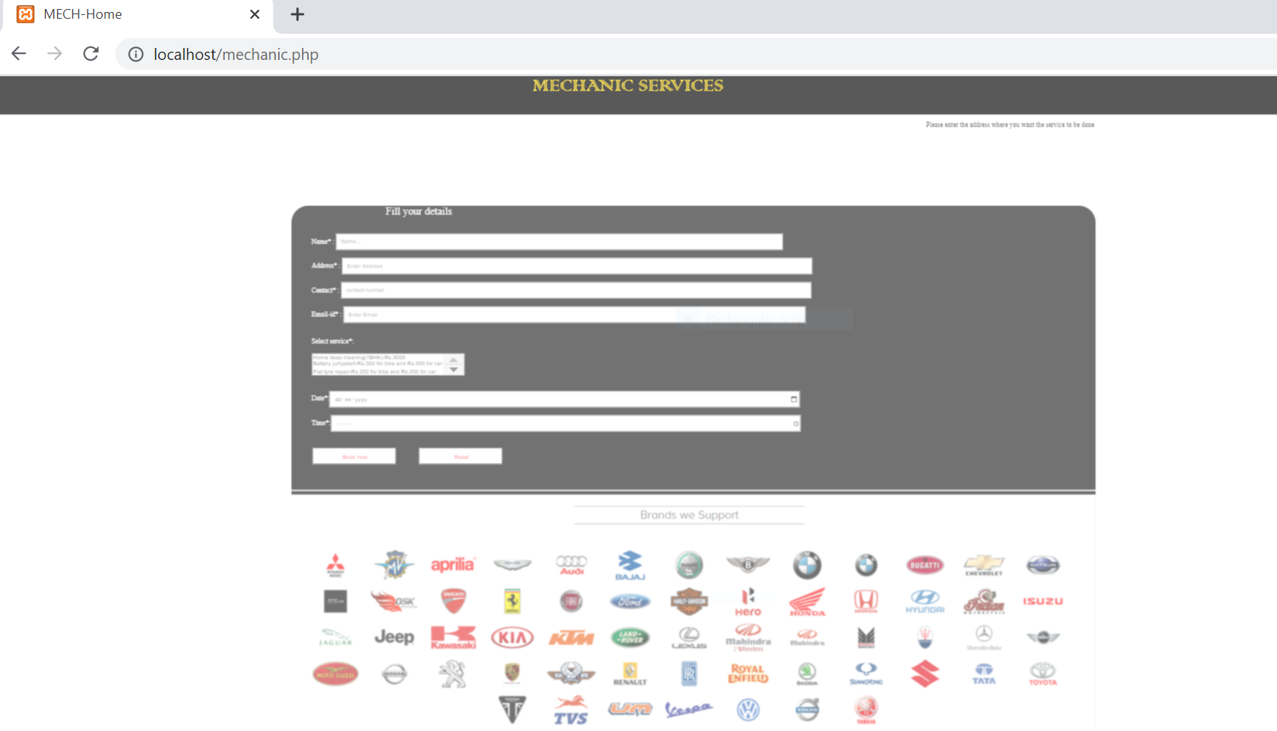

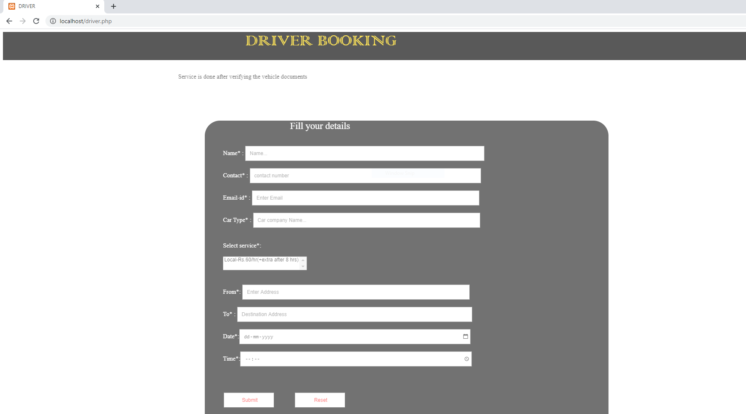

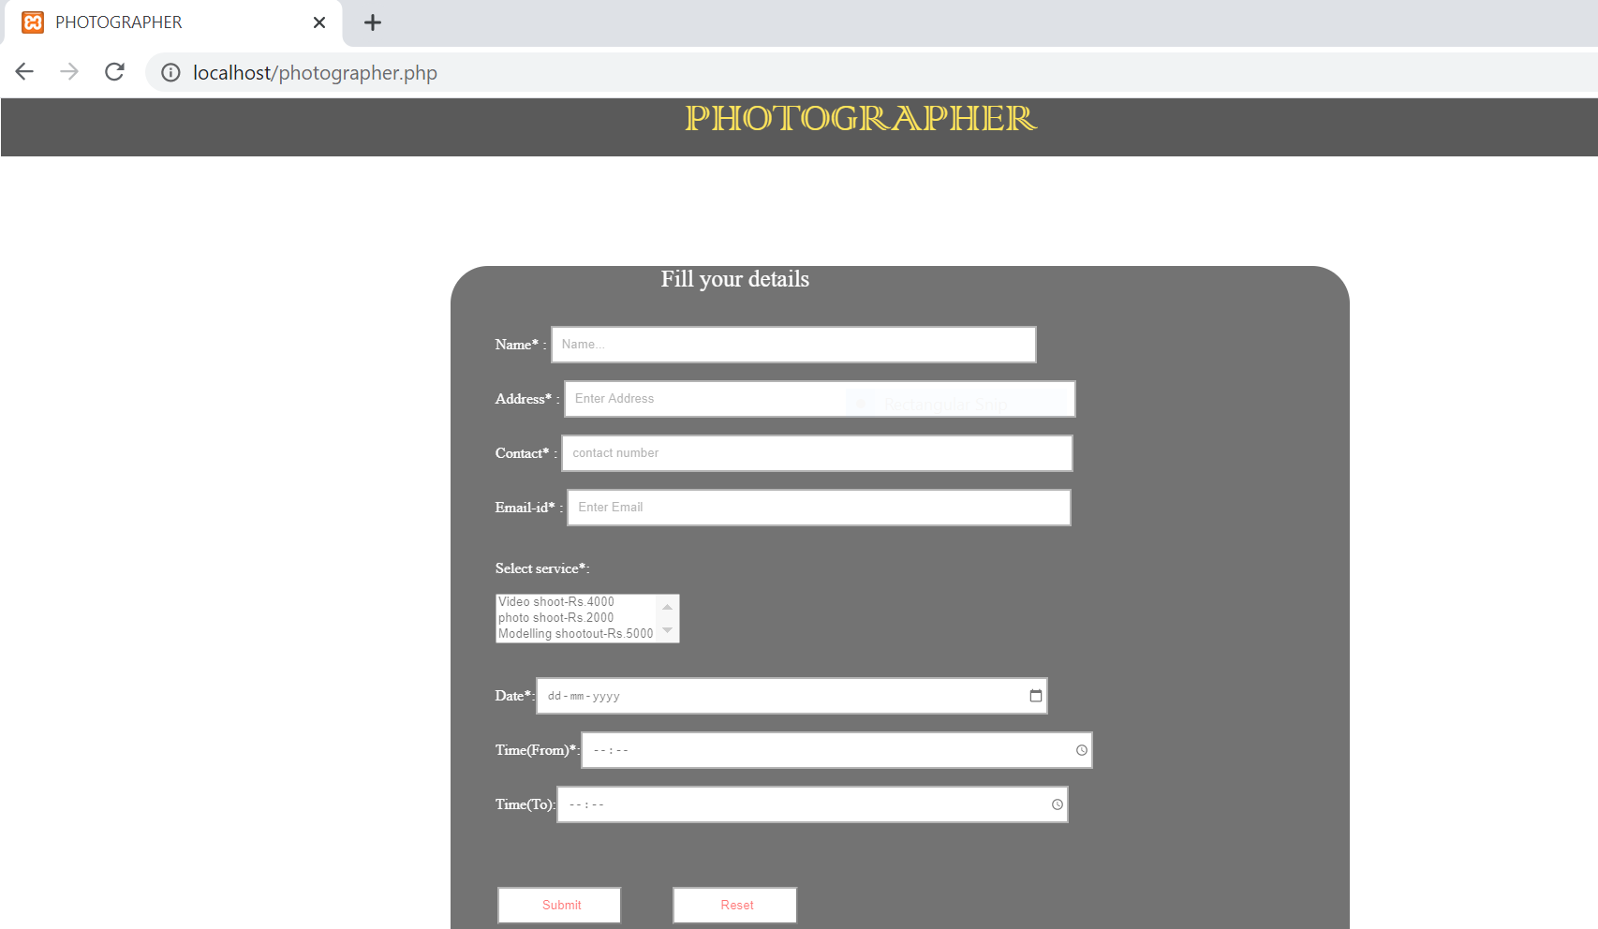

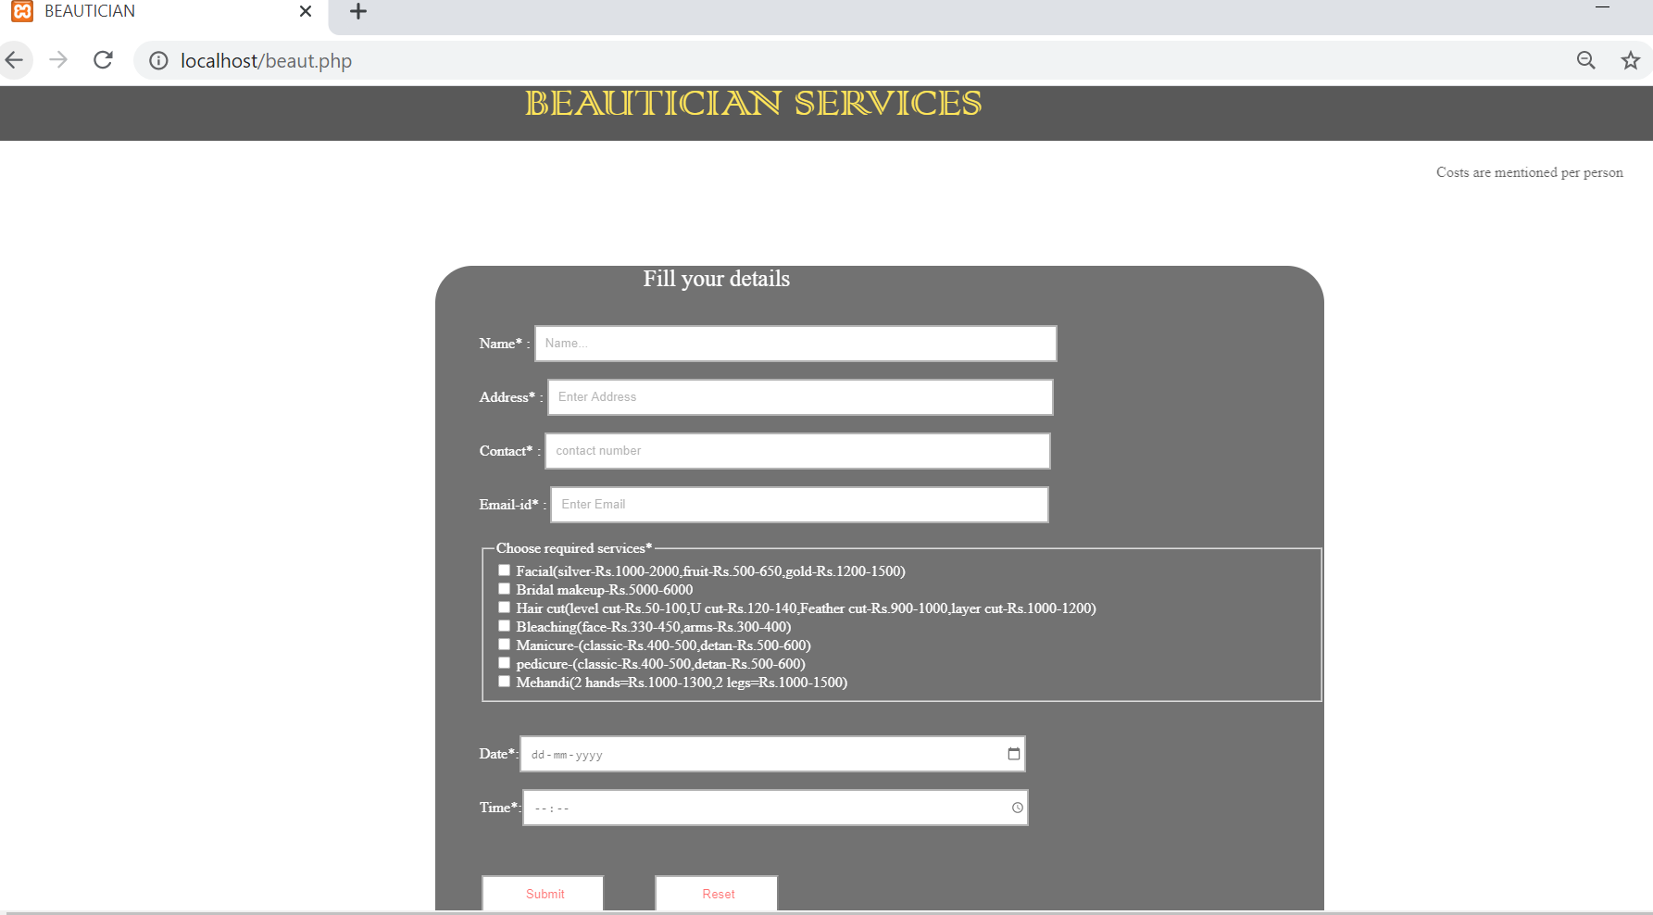

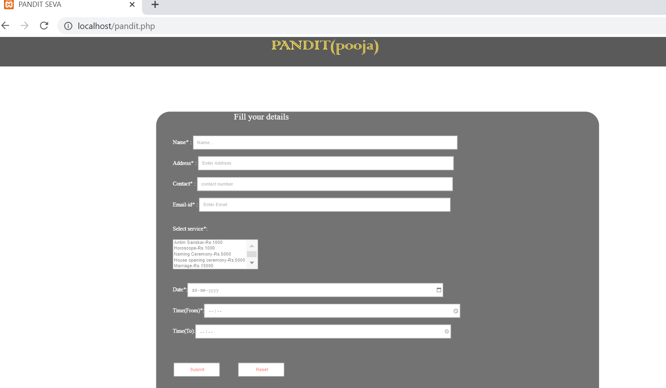

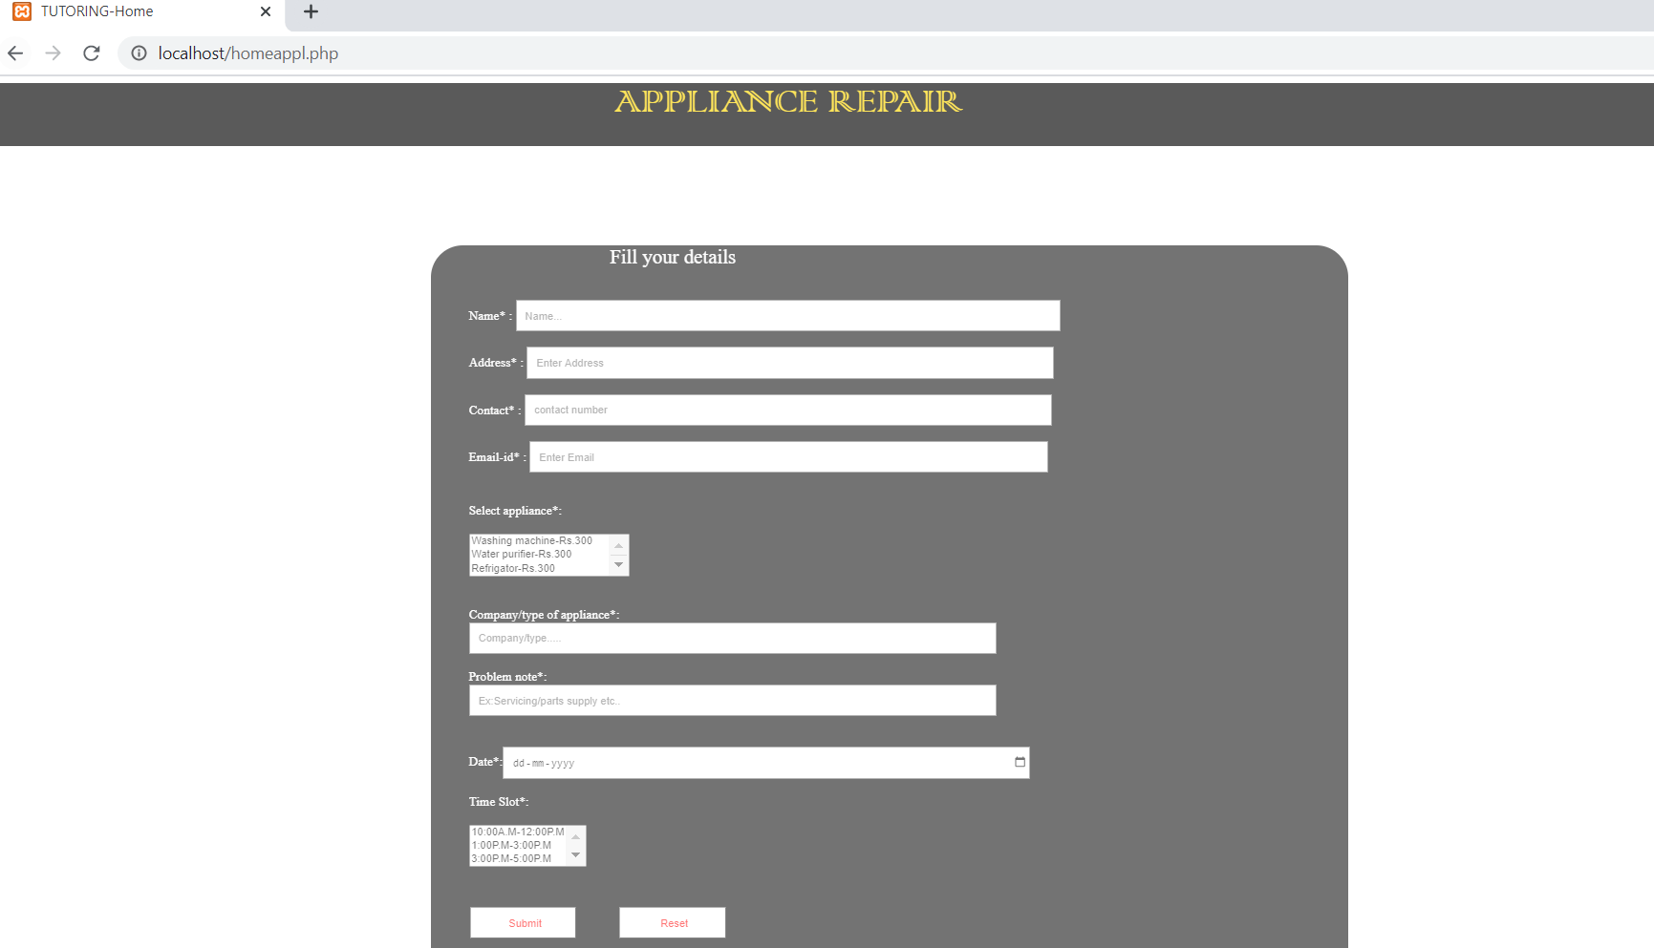

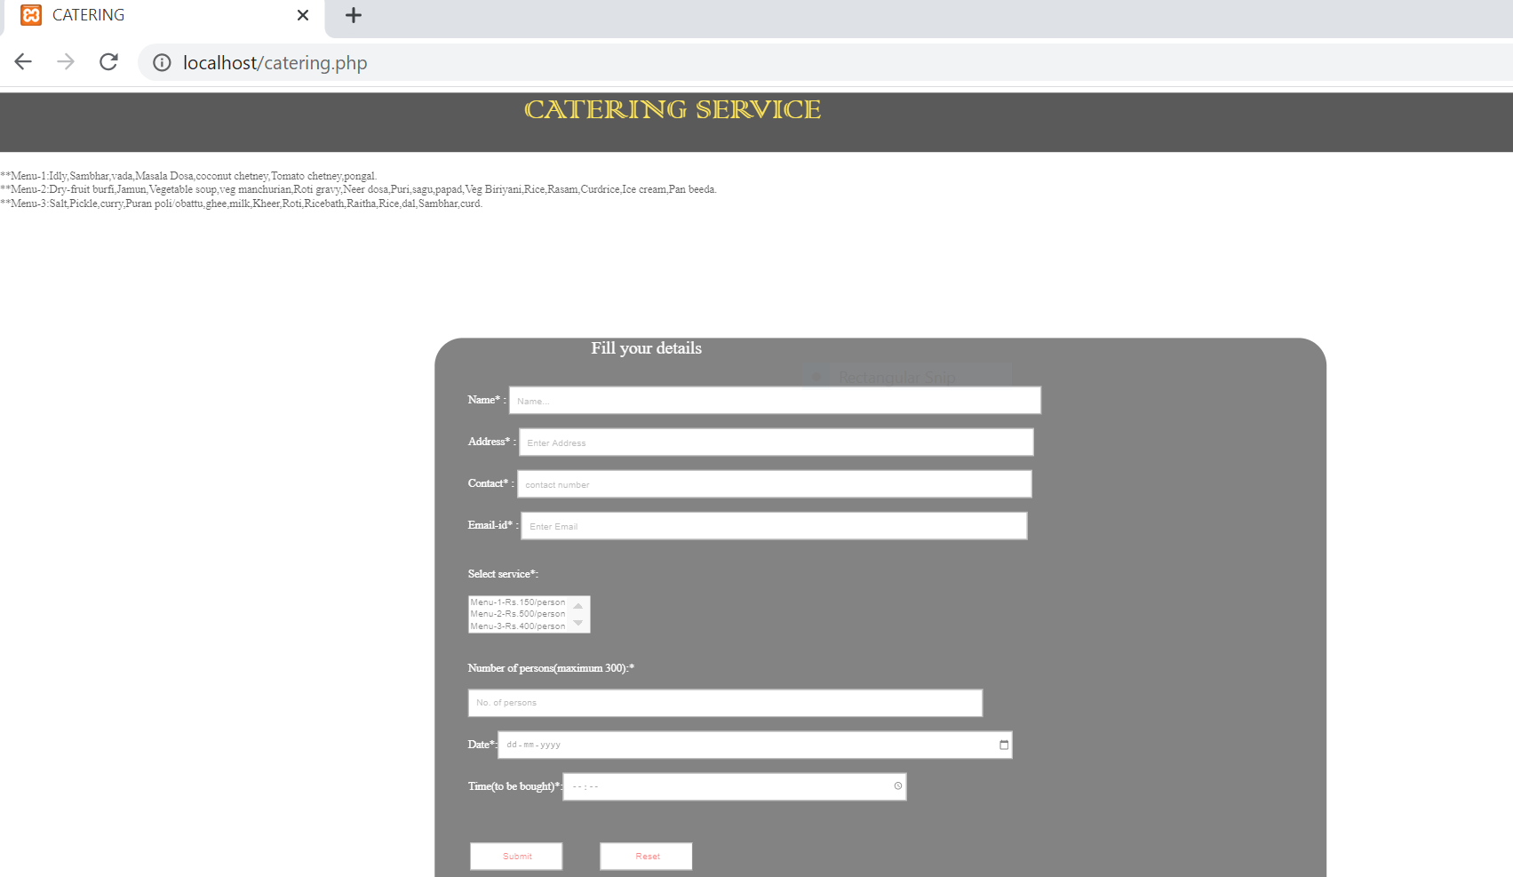

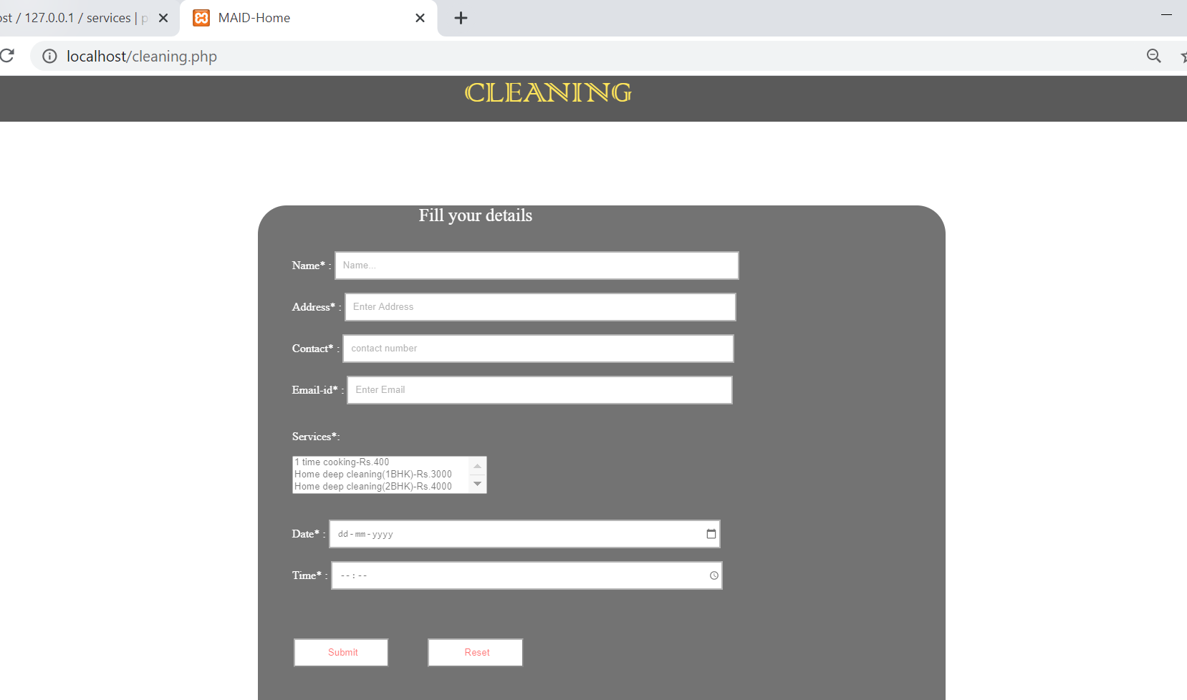

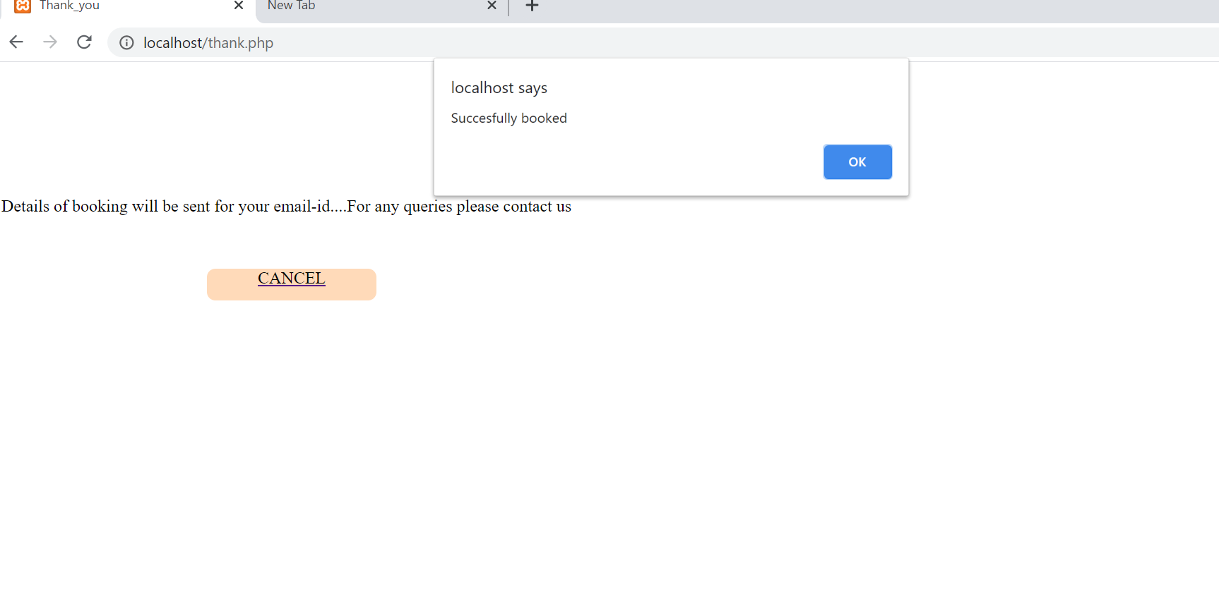

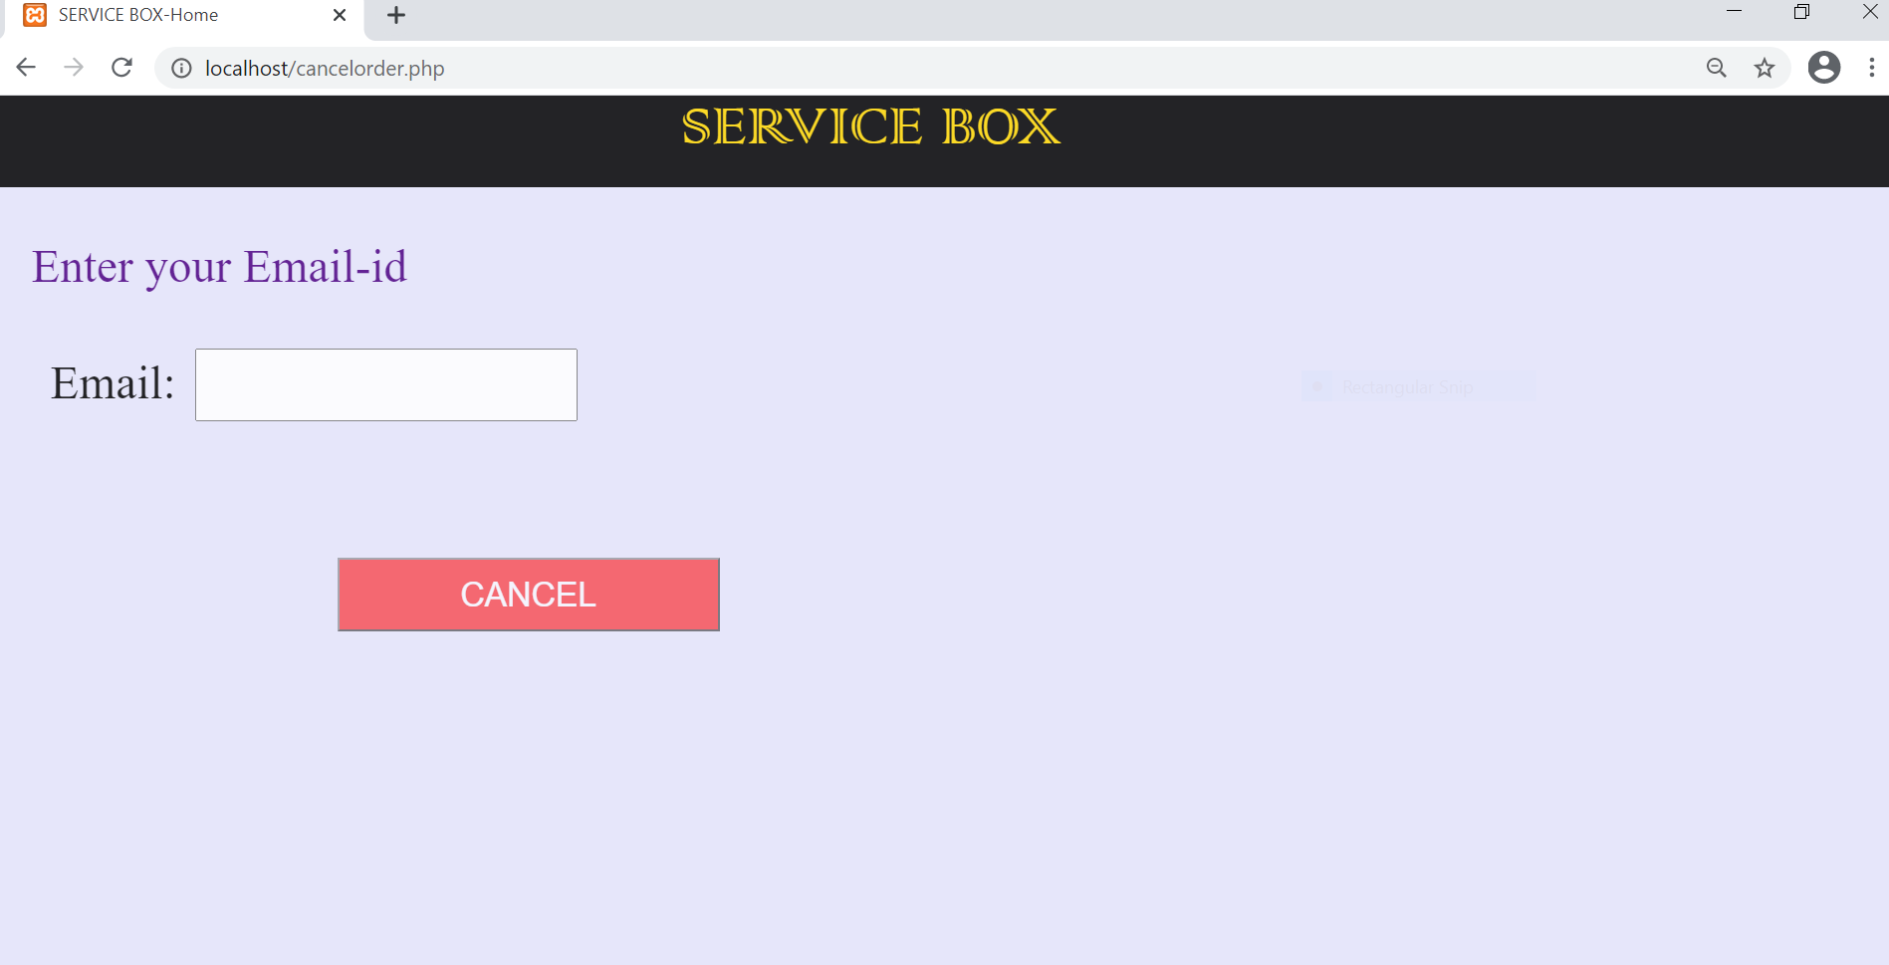

**CHAPTER 6**

**FUTURE DEVELOPMENT**

* This application is flexible so that we can add as many as services we want to provide to customers.
* In mechanical services we can add a service called fuel on-demand where the fuel will be delivered to the customer at the location, quantity, fuel type, time, date if provided by the customer.
* A reminder or a notification can be sent to the customers who use this application in regular intervals of time (Example: Beautician services).

**CONCLUSION**

* + - * The purpose of conducting this study and doing this project is to understand the significance of relational database using phpMyAdmin and web applications using html and CSS.
* Databases were made to make our lives a little easier by helping us deal with the data in a simplified manner.
* This project is designed to provide the user with easy navigation/access, retrieval of data and necessary feedback as much as possible.
* Easily accessible, error-free and reliable system
* Efficient and less time consuming.

**REFERENCES**

* [www.GeeksforGeeks.com](http://www.GeeksforGeeks.com)
* [www.W3schools.com](http://www.W3schools.com)
* www.youtube.com
* www.c-sharpcorner.com